**create database if not exists custom;**

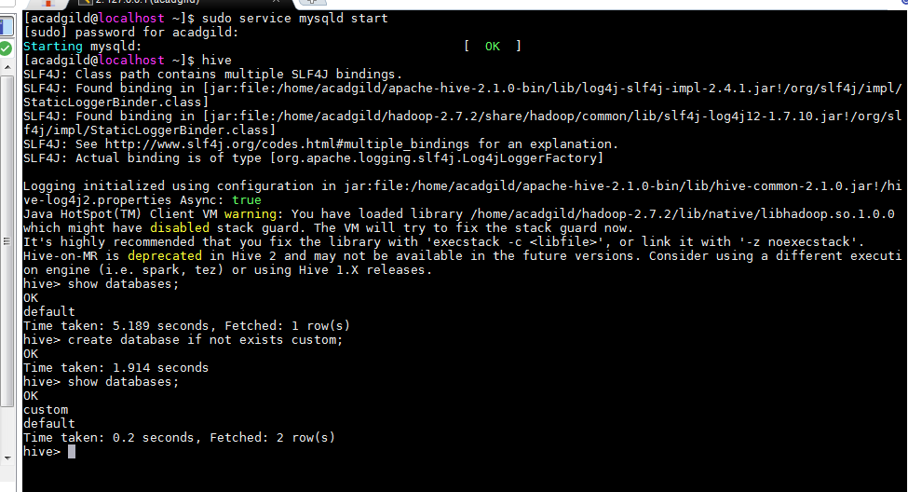

**CREATE TABLE temperature_data**

**(**

**dateOfYear STRING,**

**zipCode INT,**

**temperature INT**

**)**

**ROW FORMAT DELIMITED**

**FIELDS TERMINATED BY ',';**

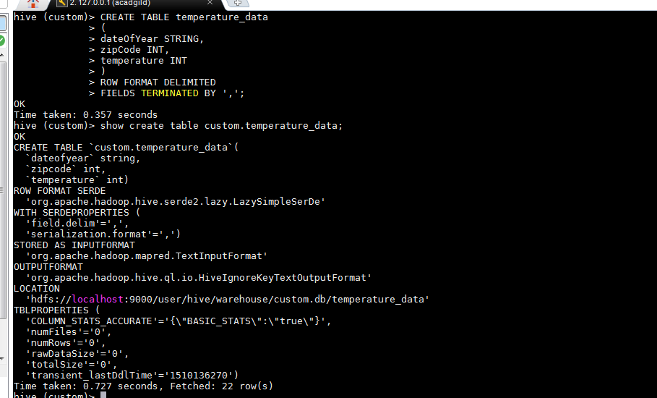

**LOAD DATA LOCAL INPATH '/home/acadgild/hadoop/dataset_Session 14.txt'**

**INTO TABLE custom.temperature_data;**

